Test Grid
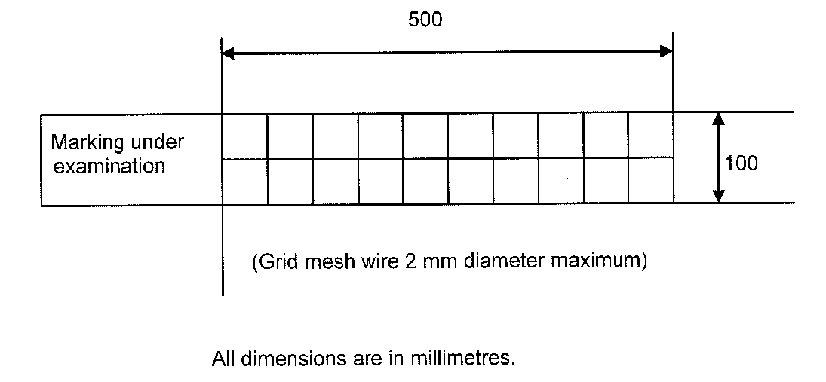

Fig 1. Positioning the test grid for assessment of degree of wear

